Excel Homework

Excel-challenge

Kickstarter campaigns

Ali Asghir

13/11/2021

1. What are three conclusions we can draw about Kickstarter campaigns?
   * 1. Peake of successful Kickstarter May to July.

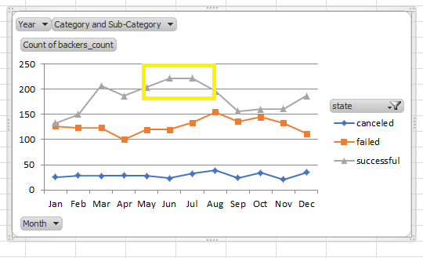

* + 1. Rapid Growth after 2013 of successful Kickstarter.

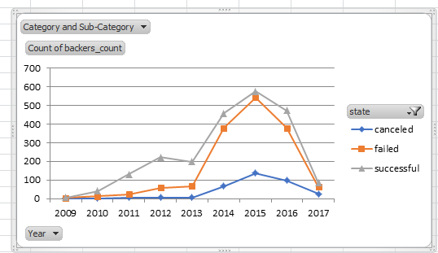

* + 1. Most successful subcategory was Theater.

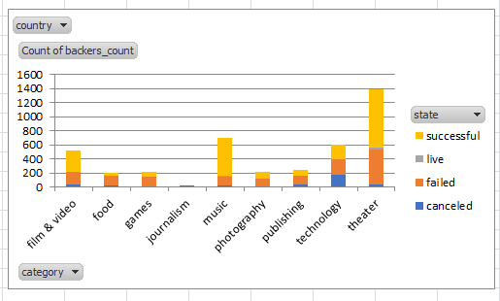

1. What are some limitations of this dataset?
   * 1. Dataset not fully represent papulation of Kickstarter.
     2. Dataset have not much information for donation types.
     3. Focus mostly on Theatre subcategory .
2. What are some other possible tables and/or graphs that we could create?

Yes! We can create table/graph of most popular category, success rate of each sub category, median, max of average donation of sub category. Average time line of most successful or least successful Kickstarter.